**Exercise**:

1. Give the path to your directory

_____________/home/student____________ _________________________________________

1. How many entries in:

Your directory: ls –l|wc –l ___________total 112__________________

ls –la|wc –l ___________total 208__________________

What is the significance of the:

. (dot) directory

for current directory

.. (double dot- directory

for parent directory

1. Give the number of entries in each of the following directories.

Hint: Answer each of a two step problem.

* **First** move to the directory (using cd path)
* **Second** execute ls –l|wc -l

1. The root directory / ________Permission denied___________
2. /bin _________________total 12988__________________________
3. /sbin __________________total 12676________________________
4. /usr _____________________total 128______________________
5. /usr/bin _____________________total 277592____________________
6. /usr/sbin ______________________total 40008__________________
7. How many users current logged onto atlas. The command **“who”** shows who is logged on.

____________1_____user___________ number

________________users | wc -l_____________ command used.

1. Using **cal** Use **man cal** to determine how to find which day of the week you were born.

On which day of the week were you born? _____Tuesday_____________

1. How can you display a calendar of 2011 on the screen?

Give the command ___________cal 2011_________________

1. Given the following hierarchical structure.

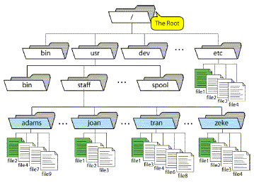

1. Give the absolute path to the **file9**

______________________/usr/staff/adams/file9___________________________________

1. If the current working directory is **/usr/staff**, give the relative path to **file9**

_______________/adams/file9________________________________________